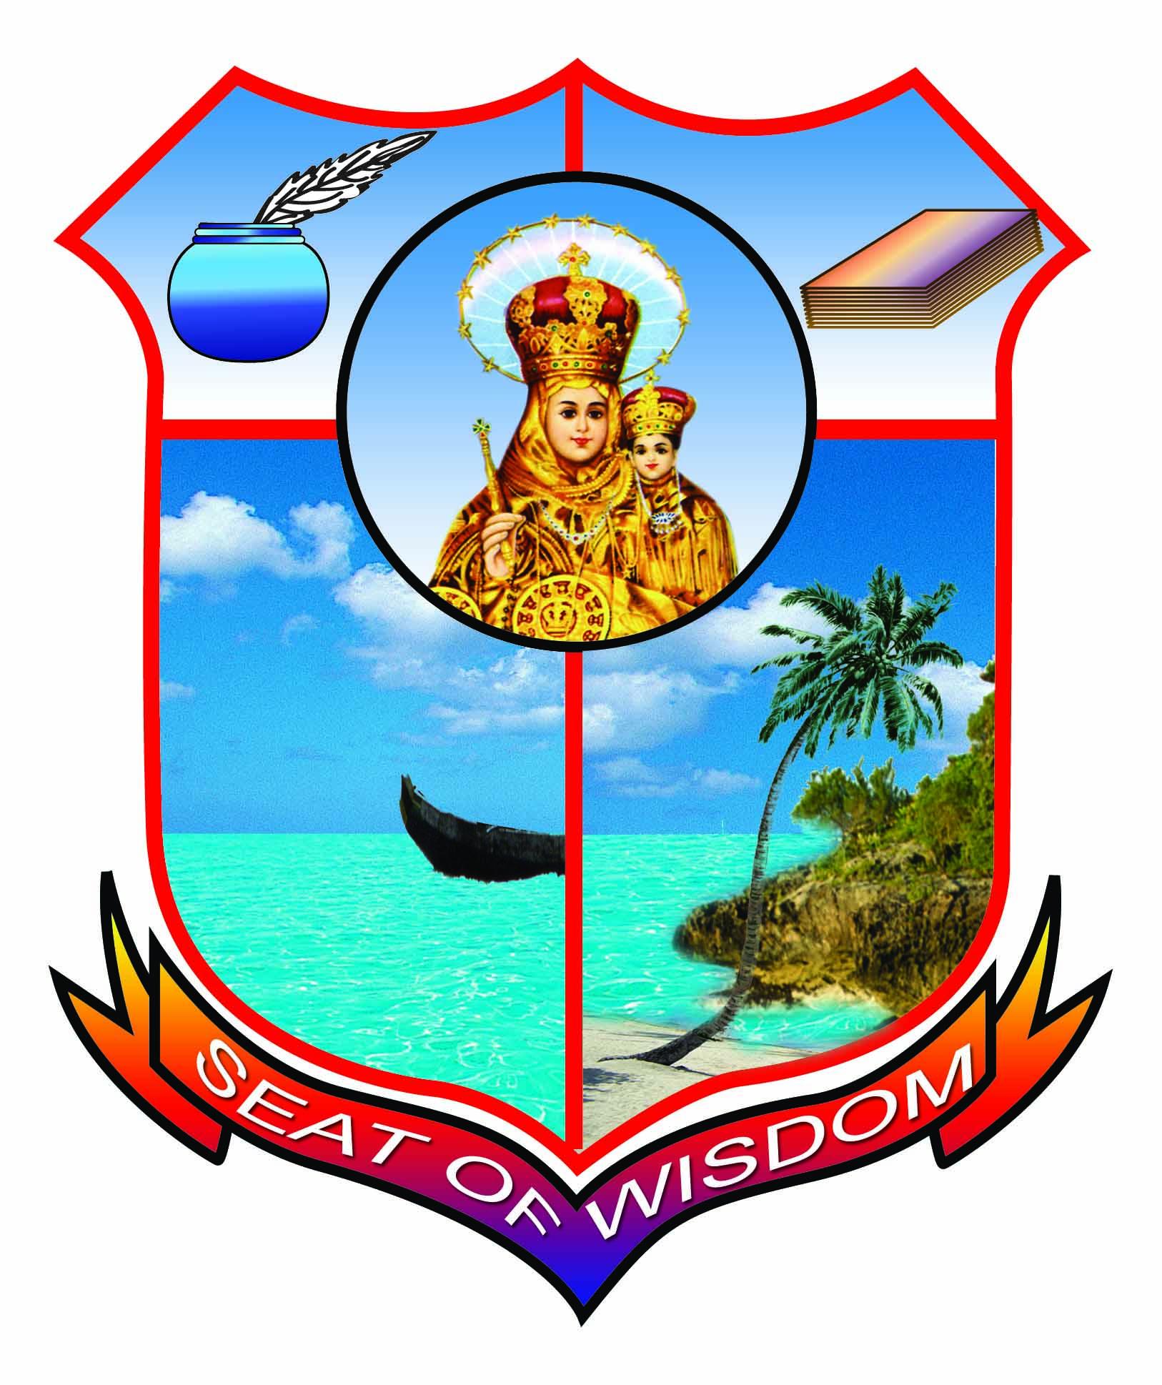
Annai Velankanni College, Tholayavattam
(Accredited with B++ by NAAC)
(Approved by UGC under section 2(f) and 12(B) status)
31st ROAD SAFETY AWARENESS PROGRAMME
23-01-2020
Programme Schedule
Time : 2.00 p.m Venue : Fr. Lucas Auditorium

- Tamilthai Vazhuthu
- Welcome Address : Dr. J. Johnson
Principal, AVC
- Inaugural Address : Dr. E. John Kulandai
Correspondent, AVC
- Special Address : Mr. K. Palanisamy
RTO, Marthandam
- Chief Guest Address : Mr. Vishwesh B Shastri, IPS
ASP, Colachel
- Prize Distribution
- Honouring
- Vote of Thanks : Dr. S. R. Brintha
Vice Principal, AVC
- National Anthem

*******************

